
Thursday, March 26 at 5:30pm
Cranberry Country Lodge
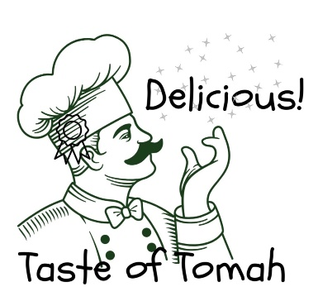

Restaurant Guidelines:
- Setup will be on Thursday, March 26. You can get into Cranberry Country Lodge as early as 8am. Everything must be set up no later than 5pm when the doors open.
- ACT will furnish plates, napkins, plasticware & tablecloths.
- ACT will print signage for each table, indicating the name of the restaurant and what they will be serving.
- Business logo must be emailed to boxoffice@tomahact.com by February 26th (if we do not already have it on file).
- Please let us know if you will need electricity for your table.
- ACT must know in advance what the restaurants will be serving. Email Lisa at boxoffice@tomahact.com by February 26th.
- Restaurants may have up to 2 different items to taste.
- Please prepare sample sizes of food for 200 guests.
- Restaurants should provide serving utensils and at least one person to serve (if you cannot provide someone, please let us know and we can provide someone for you).
- Serving tables can be cleared at 6:45pm, but you may also leave it up until after intermission and enjoy the Mr. Legs competition!

Over>>
- Taste of Tomah 2026 winner will be chosen based upon the number of votes (money) they receive in their bucket. Businesses may collect monetary votes prior to the event. ($1.00 equals 1 vote, $20.00 equals 20 votes). Donations can be turned in and calculated by ACT prior to the event to speed up the tallying process at the end of the event. Quarters count as negative votes. Each dollar in quarters equals a dollar in points removed from another team’s total votes.
- Advance tickets are $45 and will be available at tomahact.com, by calling the ACT Business Office at 608-374-7469 or in person at 901 Kilbourn Avenue, Tomah. Tables of 8 can be reserved and paid for in advance for $360 so you and your friends can sit together! Tickets purchased on the night of the event at Cranberry Country Lodge will be $50.
- All proceeds benefit the Area Community Theatre.

This will be a great opportunity to promote your establishment. Have your server talk about your menu and encourage people to patronize your restaurant.

Thank you for participating in this event. ACT greatly appreciates it!

Area Community Theatre (ACT) 901 Kilbourn Avenue, Tomah, WI 54660 ~ www.tomahact.com ~ 608-374-7469

